On-Premise SMS

❓ What is On-Premise SMS?
# Source: AI Source: Provided by: [Data Path: Persons Table -> ID Column: 1, Name_En Column: Motasem Essam] -> From: [ChatGPT] on [1/21/2026]
On-Premise SMS refers to an SMS delivery system that is physically hosted and managed within your organization’s infrastructure — typically using hardware like GSM modems, SIM cards, and dedicated SMS software.
It means you own and operate the entire system instead of using a cloud provider (like Twilio or Nexmo).

🧱 How It Works:
# Source: AI Source: Provided by: [Data Path: Persons Table -> ID Column: 1, Name_En Column: Motasem Essam] -> From: [ChatGPT] on [1/21/2026]
- You connect a GSM modem or SIM card pool to your server (via USB or serial).
- An SMS server or gateway software (e.g., Kannel, Jasmin, Gammu) runs on your local machine.
- You send/receive SMS via APIs or a custom user interface.
- Messages are routed through your local mobile operator using inserted SIM cards.

🛠️ Components:
# Source: AI Source: Provided by: [Data Path: Persons Table -> ID Column: 1, Name_En Column: Motasem Essam] -> From: [ChatGPT] on [1/21/2026]
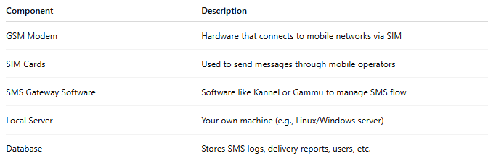

Component | Description
GSM Modem | Hardware that connects to mobile networks via SIM
SIM Cards | Used to send messages through mobile operators
SMS Gateway Software | Software like Kannel or Gammu to manage SMS flow
Local Server | Your own machine (e.g., Linux/Windows server)
Database | Stores SMS logs, delivery reports, users, etc.

📊 Features:
# Source: AI Source: Provided by: [Data Path: Persons Table -> ID Column: 1, Name_En Column: Motasem Essam] -> From: [ChatGPT] on [1/21/2026]
- Works without internet
- Local message routing
- Supports bulk SMS (with multi-SIM setups)
- Full control and customization
- Can integrate with internal apps via API or CLI

✅ Pros:
# Source: AI Source: Provided by: [Data Path: Persons Table -> ID Column: 1, Name_En Column: Motasem Essam] -> From: [ChatGPT] on [1/21/2026]
- Full control over infrastructure
- Lower per-message cost (especially in local campaigns)
- Good for offline environments
- Avoids third-party data sharing

❌ Cons:
# Source: AI Source: Provided by: [Data Path: Persons Table -> ID Column: 1, Name_En Column: Motasem Essam] -> From: [ChatGPT] on [1/21/2026]
- Requires hardware setup & maintenance
- Scalability limits (SIM cards often capped per modem)
- High upfront cost
- SIM card carrier limitations (e.g., daily sending limits)
- Compliance risks if messages are unsolicited

🆚 Comparison: On-Premise vs. Cloud-Based SMS
# Source: AI Source: Provided by: [Data Path: Persons Table -> ID Column: 1, Name_En Column: Motasem Essam] -> From: [ChatGPT] on [1/21/2026]
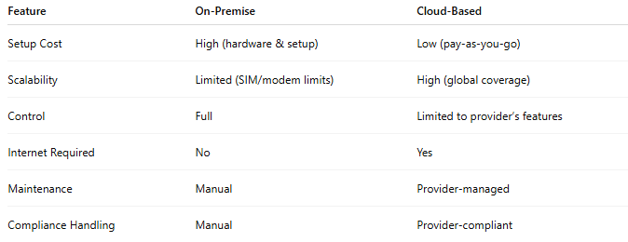

Feature | On-Premise | Cloud-Based
Setup Cost | High (hardware & setup) | Low (pay-as-you-go)
Scalability | Limited (SIM/modem limits) | High (global coverage)
Control | Full | Limited to provider’s features
Internet Required | No | Yes
Maintenance | Manual | Provider-managed
Compliance Handling | Manual | Provider-compliant

🧰 Common Use Cases:
# Source: AI Source: Provided by: [Data Path: Persons Table -> ID Column: 1, Name_En Column: Motasem Essam] -> From: [ChatGPT] on [1/21/2026]
- Local businesses sending promotional SMS
- Closed systems (e.g., internal notifications in factories or banks)
- Areas with no stable internet but mobile signal
- Organizations needing full data ownership

